AN EFFICIENT HEALTHCARE MONITORING AND PRE-EMPTIVE AMBULANCE CONTROL THROUGH TRAFFIC SIGNALS

Vasanthan V
Dept. of Information Technology
Rajalakshmi Engineering College
Chennai, India
vasanthan.v.2016.it@rajalakshmi.edu.in

Teja Sai Vignesh D
Dept. of Information Technology
Rajalakshmi Engineering College
Chennai, India
tejasaivignesh.d.2016.it@rajalakshmi.edu.in
Selvabharathi S
Dept. of Information Technology
Rajalakshmi Engineering College
Chennai, India
selvabharathi.s.2016.it@rajalakshmi.edu.in

Mrs. S Sree Subha
Dept. of Information Technology
Rajalakshmi Engineering College
Chennai, India
sreesubha.s@rajalakshmi.edu.in

ABSTRACT
Monitoring the pulse, heart beat rate and oxygen levels of a person in an ambulance and then shifting the person to the emergency ward and then continuing the monitoring is what being done usually. The monitoring is stopped in the time when the person is shifted from the ambulance and admitted in the emergency ward. This is a big disadvantage because there is chance of drop in oxygen or pulse levels at any particular time. We eliminate this disadvantage by installing pulse sensor , temperature sensor , gps , pressure sensor , gas sensor in the stretcher itself and all these can be connected to a person’s body and can be monitored continuously . All these data are displayed in a webpage using IOT. The same stretcher can be used in emergency ward and the data of the person is not lost at any time period. Using nrf sensors , the ambulance makes a communication with the traffic signals located on the way of the ambulance and makes it to turn green until the ambulance passes through it. Therefore the ambulance can reach the hospital soon.
Keywords : IOT, GPS, pressure, pulse, mobile app, temperature , NRF

INTRODUCTION
The ambulance plays a major role in saving lives. There are a lot of hindrances in the way of an ambulance reaching the hospital. One such important hindrance is the traffic. The traffic in the way of ambulance needs to be cleared. To resolve this problem many technologies have been introduced. One such technology is the use of RFID. But the problem with the RFID’s is that communication between ambulance and traffic signal occurs only when the ambulance is too close with the traffic signal. To encounter this drawback we are using Nrf sensors(Near-far communication ) in our proposed system . This nrf sensors is attached with the ambulance and with the traffic signals. When the ambulance comes near the traffic signal , the corresponding traffic signal turns green until the ambulance passes through it. Even in a 4 way junction road , the corresponding traffic signal is turned green and other traffic signals are not disturbed . Thus the proposed system helps the ambulance to reach the hospital on time.
Another problem that happens in an ambulance is monitoring the vital data such as heart beat rate, temperature , pressure within the ambulance and the problem in this is the data is not continuously monitored . The data is not monitored when the person is shifted from the ambulance to the emergency ward. To encounter this problem we have come up with a solution wherein all the sensors like the heart beat rate sensor , pressure sensor , humidity sensor are all situated in the stretcher itself. And this stretcher is carried to the emergency ward . Such that there is continuous monitoring of data, We ensure that the data is not lost in the middle .
Internet of Things (IOT) is a rising technology. Using IoT, we enable a real time data transfer of the data that is being monitored in the ambulance. This helps the doctors in the hospital to do the suitable treatment according to the levels of data. This also helps the doctors to guide the paramedics in a most efficient way.

RELATED WORK
Aprita K.M et al. proposed a system [1] that aims at collecting and sending the patient’s information to the hospital prior to the patient. Apart from the basic devices present inside most of the ambulances like emergency medical kit, two types of stretchers, glucometer, portable oxygen cylinder, defibrillator, ECG and ventilator also using various sensors, this system continuously monitor the patient’s vital health parameters. This system reduces the time wasted in fulfilling hospital formalities.
Syed Misbahuddin et al. proposed a system [2] that stores real – time data locally for a short time for the observation of on-board paramedics . The data is also displayed graphically on an LCD screen of the host computer The hospital staff can scrutinize the patient’s health status generated from the ambulance in real time web page while the patients are on the way to the hospital’s. The doctors can view the patient’s health conditions and may communicate with the paramedics inside the ambulance to ossify the patients. The proposed system using Internet of Things (IoT) for real-time data transfer . The proposed system does not have a preemptive traffic control system.
Qurrat UI Ayan et al. proposed a system [3] which monitor's for emergency patient even during transportation to hospital in an ambulance. A low-power wireless wearable monitoring device is implemented using embedded system, sensors , IOT and GSM technology . This project performs three main functions. At first it monitor's the health of the patient then tracking the Ambulance in which patient is present and third one is to send above two information to the Hospital or Doctor using GSM and the vital parameters values to the cloud using Wi-Fi Technology.
Elangeswari et al. proposed a research [4] in which first a semantic data model is proposed to store and interpret IOT data. Then a resource-based data pervade model is designed to acquire and process IOT data far and wide to improve the accessibility to IOT data resources. Finally, an IOT based emergency monitoring system and using it for quick medicare of patients is developed.
S. Dhivya et al. proposed a system [5] to control traffic light signals using IOT. It helps the ambulance to reach the hospital soon and also save the patient life. It is also used to send location of the ambulance reach the traffic signal for prior arrangements to manage the traffic The project is concentrated on controlling the traffic lights from the ambulance and making free way automatically without any disturbance to public. The project is used to save the time of delay in most efficient way to save life .This system uses a timer and arduino for traffic signal control. Problem with traffic signal control may occur in a 4 way junction.
Irin Sherly et al. proposed a system [6] that connects the ambulance with the IOT which has biomedical sensors like the heartbeat rate sensors, temperature sensors , ECG sensors that will sense and detect the injured person’s health conditions and update these information to the nearby hospital server . And also this system has a finger print scanner that takes the finger print of the patient and sends to the hospital server and the server will search for the patient’s fingerprint in the cloud and fetch the personal details of the person then automatically registers the patient’s admission form
S.N.Sivaraj et al. proposed a system[7] that consists of two important things. At first the basic information and status of patient is collected in the ambulance by the means IOT (Internet Of Things ) and make it available to hospital before ambulance reaches the hospital .The second section is control traffic lights from the ambulance and makes clearance for its path automatically .Thus this project allows us to save the time of major delay and improved efficient and economical manner.
Deepali Ahir et al. proposed a system[8] with Intelligent Traffic Control System for ambulance. The proposed system clears the traffic congestion, turning all the signal which in red lights to green on the path of the ambulance. The system consists of an android application which log the details of ambulance on its network. In case of emergency situation , if the ambulance struck on its way , the system sends an emergency message to the traffic signal server along with the direction where it wants to travel and with this the current position with the help of Global Positioning System. Based upon the current position of the ambulance, the nearest signal is identified. The particular signal is made green till ambulance crosses it, latter it becomes to normal mode. In this way it becomes a life saver project as it saves time during emergency by controlling the traffic lights. Problem occurs when the ambulance crosses a 4 way junction.
Syed Mohd Faisal Malik et.al proposed a system [9] that helps in navigating the traffic by using a decisive algorithm and round robin algorithm to find the Optimum path through the traffic . Raspberry Pi is used to manage all components collectively and individually. Total traffic in a zone is determined by the help of IR sensors which used RFID to distinguish high preference vehicles such as ambulance and VIPS from day to day traffic.

PROPOSED METHODOLOGY

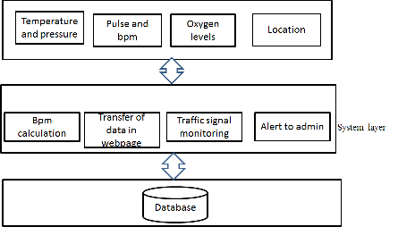
Figure 1: Architecture diagram

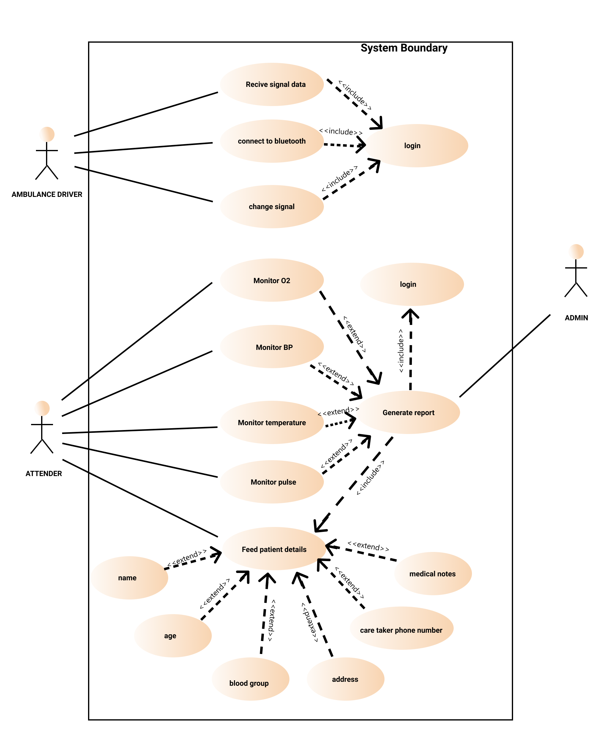
Figure 2: Use Case diagram

Monitoring of vital data
The vital data such as temperature, heart beat rate and pressure of a person in emergency is measured using the heart beat sensor, pressure sensor, temperature sensor, respiratory sensor. These sensors are attached to the stretcher itself in the ambulance. The same stretcher is used in the hospital too.

Real-time transfer of data using IOT
Using IOT, we display the vital data in a webpage dynamically. The values get updated automatically without refresh. This technique enables the doctor to know about the patient before the patient arrives in the hospital. This also enables efficient communication between the doctor and the paramedics.

Pre-emptive ambulance control
A mobile app with IOT controllers which continuously sends/receive the next nearest signal and enable the driver to control the signal by changing the traffic lights, at this moment, the precedence of traffic lights are given to the ambulance driver, once he passes away the signal, he may turn it to normal, Therefore the ambulance can reach the hospital soon.

Ambulance | 1
Normal | 0
Table 1: Precedence Table

We have a kit for the ambulance driver, and install a kit in traffic signal zone.The kit, which ambulance driver has, contains NRF and Bluetooth module with a UART micro-controller(Arduino-Uno) controlling them, it allow the ambulance driver to connect his mobile device to the kit.
The driver will have an app, which can show up the signal, which is upcoming to him. And allow him to select the way he want to go.
On selecting the way, the traffic light will be changed, As we have another NRF and Arduino kit in the signal zone, this kit will becon the available number of signal and notify to the kit in ambulance which is connected to the driver’ mobile app.
In order to select the right signal we feed every signal name with the help of campass, the signal facing its direction is named correspondingly, as north, south, east, west. With this the ambulance driver can find the right signal, he want to turn green, as he too have a compass showing the direction.
We also concern safety of this wireless Transmission/Reception, which we don’t want to be interfused with other devices, So we apply Caesar cipher Encryption technique.The traffic signal located on the way of the ambulance is turned on green till the ambulance passes through .
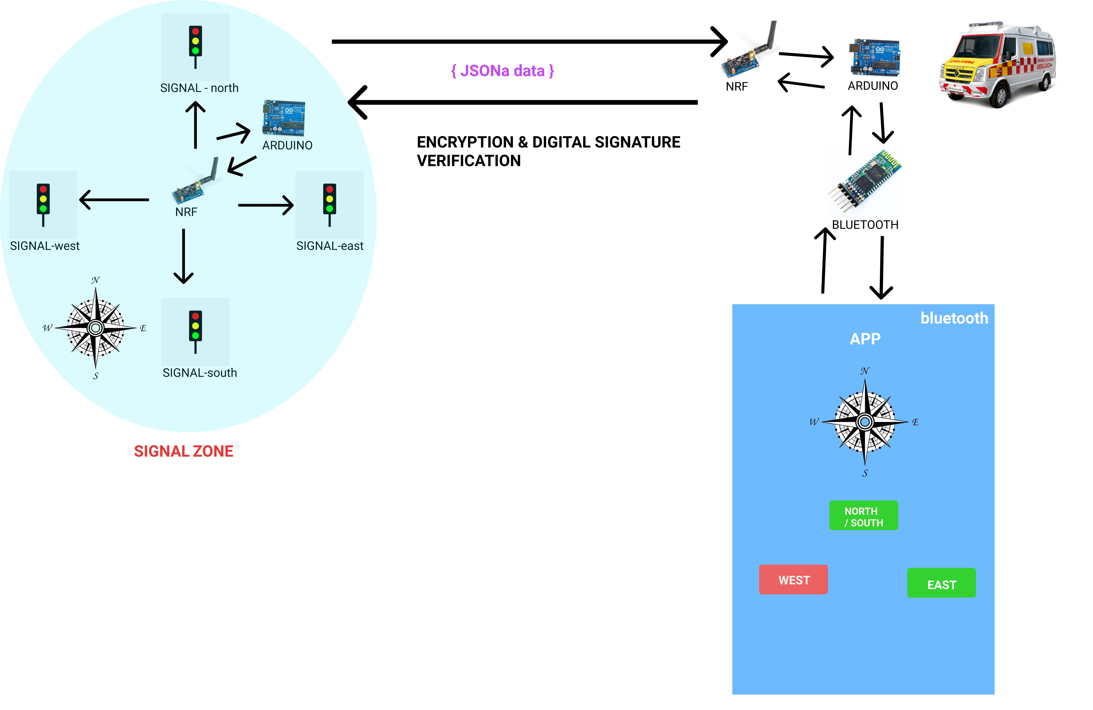
Figure 3: Mind Chart

Encryption Algorithm for Transmission/Reception
It is a type of substitution cipher in which each letter in the plaintext is shifted a certain number of places down the alphabet.
For encrypting:
C(x) = (x+k) mod 26
For Decrypting:
P(x)=(x-k)mod26
Where, C(x) is the ciphertext
P(x) is the plaintext
x is the plaintext
k is the number of shift

RESULTS

Monitoring of vital data
The temperature, heart beat and pressure sensor is attached to the stretcher and the patient, the data coming out of these sensors is collected and sent to the web server, which further given to the webpage. This webpage is accessible to the hospital, with which the doctor can know the live health condition of the patient and they can assist the paramedics. This technique is known as Internet Of Things(IOT) .

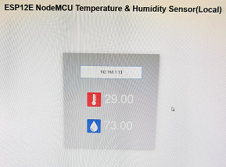
Figure 4: Monitoring of data in webpage

Pre-emptive ambulance control
We have installed two kits, one will be in ambulance and another will be installed in the every signal.
The kit in the ambulance contain Bluetooth module, NRF, RFID sensor. Bluetooth module helps in connecting the kit to the app we have build, NRF help in communicating with the signal for changing the lights. RFID is used to ensure the right user is accessing the kit. At first the driver used to connect with the kit’s Bluetooth named “ambulance”, Once the driver is paired to the device, he can switch to the app. Here he will be checked for the permission and Bluetooth connectivity. Now the driver will be asked to keep his RFID tag to verify himself, if right user, then allowed into the app, if unauthorized user then a alert sound and a emergency message is sent to the control room or any other emergency department. After that he will be allowed to select the kit’s Bluetooth and connect to it, if he choose a wrong Bluetooth device, a prompt with warning message will be displayed. Then the user is allowed to the main page where he can see the Bluetooth device and its MAC Id he is connected to, a compass to select the right signal, and four buttons, which is used to turn the signal green.
The kit in the signal contains a NRF sensor, which keeps on bacons the available number of signal. The signals were named according to the compass direction in that zone, so that the driver can find the right signal.
On receiving the signal data to the app, only the available signal button is enabled by which the driver can be notified, Then the driver can turn the signal green by clicking the button of his way, Once he cross the signal, he can click on the same button to turn the signal to the normal mode.
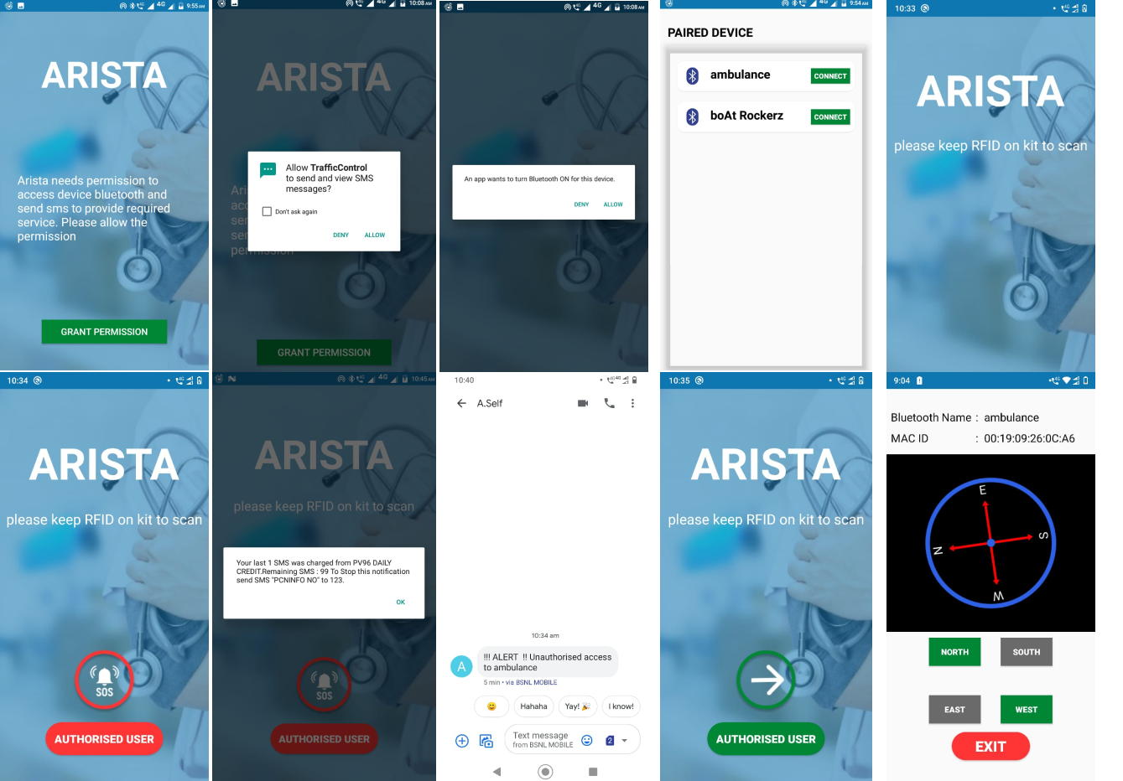
Figure 5: Android app UI

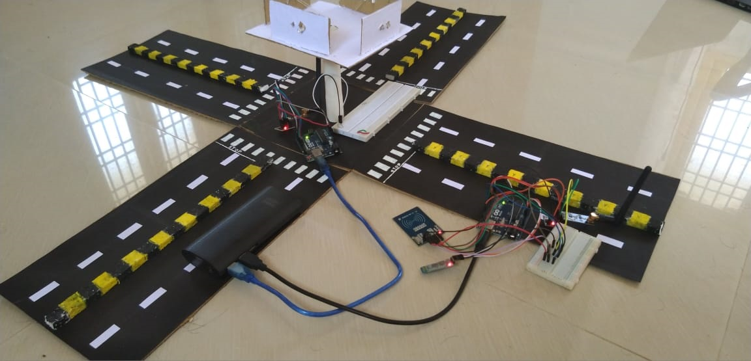
Figure 6: Working Model

CONCLUSION
The proposed system helps in monitoring the vital data of a patient in the ambulance and enables real-time data transfer of vital data to the hospital. The vital data is also displayed in the webpage and the values are updated dynamically. This enables the doctor to know about the patient before the patient arrives in the hospital, suitable treatment can be given to the patient. Our proposed system also enables efficient communication between the doctor and the paramedics. Our proposed system also enables fast transportation of the patient by using NRF sensors(near far communication) that helps in controlling traffic signals . The traffic signal in the way of ambulance turns green.

REFERENCE
[1] Aprita K.M, K.S Asha , T. Ashwan , Janvi Maddi, M.P Sunil,“Health monitoring system for ambulance “, ISSN: 2321-9653 , 2019.
[2] Abdul Rahman Alahdal , Junnaid Ahmed Zuairi , Muhammad Arshad Malik, Syed Misbahuddin ,“IoT based Ambulatory vital data signs data transfer system “, Journal of Computer Networks and Communication, Volume 08 , Article ID 4071474, 2018
[3] Veena Saraf , Qurrat UI Ayan , “ An IOT based ambulance tracking with patient health monitoring system using GPS and GSM “ , Journal of Engineering Research and Application , ISSN :2248-9622 Volume 9, Issue 6 , June 2019.
[4] Elangeswari , R. Poorni, R. Rashmi , M. Varalakshmi , ”Emergency medical services in Internet of Things “ , Intrenational Journal of engineering Technology in Computer Science and electronics , ISSN : 0976-1353 volume Issue 3 , April 2016.
[5] S. Dhivya , M. Palani , S. Saravanakumar , S.Venkatesh , M. Vikhneswaran , “ IOT based traffic signal control for ambulance “ , International Journal of Pure and Applied Mathematics , volume 118 , ISSN : 1314-3395 ,2018.
[6] S. Irin Sherly, A. Maria Soitham Princy , S. Monisha , K. Nandhini ,”Smart ambulance rescue system with patient health monitoring using IoT , International Journal of Advanced Research in Science , Engineering and Technology , Vol 6 , Issue 2 , February 2019, ISSN : 2350-0328.
[7] S.N Svaraj , K. Vigneshwaran . S. Vigneshwaran , M.Vishnu Priyan , “IOT ambulance with automatic traffic light control , SSRG International Journal of Industrial Engineering – Special Issue ,March 2017.
[8] Deepali Ahir , Mihir Shah, Pradnya otre , Saurabh harade , Sayali Nagane , ”Intelligent traffic control System for smart ambulance , International Journal of Advanced Research in Science , Engineering and Technology , volume : 5 Issue : 6 , June 2018 .
[9] Torez Nafis , Syed Mohd Faisal Malik ,”IoT enabled traffic control model using raspberry pi “ , International Journal of Advanced Research in Computer Science , Volume : 9 May-June – 2018.

